**Raspberry Pi Marine Heatwave Simulator project**

Amelia Ritger

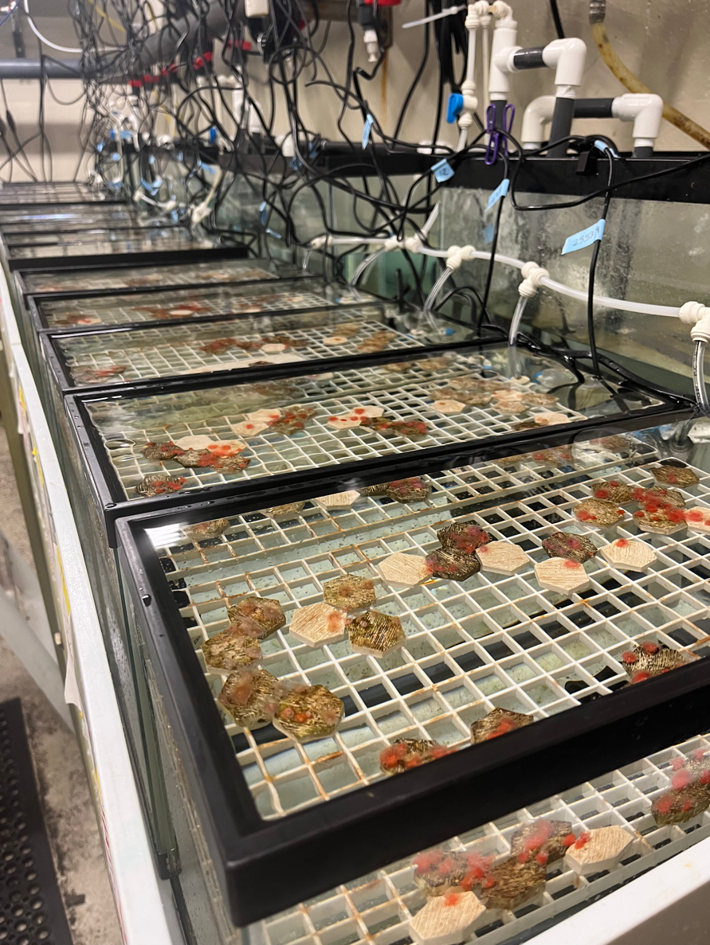

This work is licensed under the [Apache License 2.0](https://github.com/ameliaritger/MHWsim/blob/main/LICENSE).

**Contents**

1. Introduction
2. Materials, Tools, and Consumables
3. Preparing the Raspberry Pi
4. Preparing the Relay HAT
5. Preparing the Perma-Proto HAT
6. Assembling the system
7. Adapting the code to your experiment

**1. Introduction**

Marine heatwaves have generated growing interest among scientists and the public as heating events increase in frequency, intensity, and duration due to anthropogenic climate change. Anomalously warm water events often have devastating impacts on marine ecosystems and the human societies that rely upon them by disrupting ecological, social, and economic systems. Experimental studies are a critical component of research programs aimed at broadening our understanding of the ecological effects of marine heatwaves; however, traditional experimental methods often do not accurately reflect the complexity of marine heatwaves as they occur in our oceans.

For this project, I used a Raspberry Pi as a temperature controller to generate marine heatwaves that match the dynamic nature of real-world heatwave events in the lab. This experimental set-up allows for full customization, allowing researchers to re-create marine heatwaves that have happened in the past or produce entirely new heatwave scenarios based on future projections. By adopting this more realistic experimental approach, scientists can design marine heatwaves studies that are more realistic and generalizable in a world where marine heatwaves are the new norm.

This document provides guidance on the construction of the Raspberry Pi Marine Heatwave Simulator system. ***This document is an early work in progress, please stay tuned for updates!***

**2. Materials, Tools, and Consumables**

|  |  |  |
| --- | --- | --- |
| **ITEM** | **QUANTITY** | **PRICE** |
| **Tools** | | |
| Soldering iron | 1 | varies |
| Wire strippers | 1 | [~$7](https://www.adafruit.com/product/147) |
| Needle nose pliers | 1 | [~$3](https://www.adafruit.com/product/146) |
| Flat head and Phillips head screwdriver | 1 | [$1.50](https://www.adafruit.com/product/3284) |
| Razor blade | 1 | [~$5](https://www.amazon.com/Single-Edge-Razor-Blade-Pack/dp/B08FW6CYG5) |
| **Materials** | | |
| Raspberry Pi 4 (4GB) | 1 | [$55](https://www.digikey.com/en/products/detail/raspberry-pi/SC0194-9/10258781) |
| microSD card (32GB+) | 1 | [~$10](https://www.amazon.com/SanDisk-Ultra-microSDXC-Memory-Adapter/dp/B073JWXGNT/) |
| RPi Relay Board | 1 | ~[$18.99](https://www.amazon.com/gp/product/B07CZL2SKN) |
| Perma-Proto HAT | 1 | [$4.95](https://www.digikey.com/en/products/detail/adafruit-industries-llc/2310/5629417) |
| DS18B20 waterproof thermistor | 1 | [$11.95](https://www.digikey.com/en/products/detail/sparkfun-electronics/SEN-18367/15189222?s=N4IgTCBcDaIIwFYBsAOAtAZQKIDk1xQGYkB2NHAERAF0BfIA) |
| 1/8-1/4W 2.2-4.7k $Ω$ resistor | 1 | [~$0.10](https://www.digikey.com/en/products/detail/lumimax-optoelectronic-technology/CF1-4W2K2JTB/16708111) |
| Extension cord | 1 | [~$6](https://www.homedepot.com/p/10-ft-16-3-SJTW-13-Amp-125-Volt-1625-Watt-Lighted-End-Indoor-Outdoor-Black-Heavy-Duty-Extension-Cord-16310FTBK/314613505) |
| RPi waterproof housing | 1 | varies |
| **Consumables** | | |
| Lead-free solder | 1 | [$6.75](https://www.digikey.com/en/products/detail/nte-electronics-inc/83-7068-1402/12158031) |
| 22 AWG solid core wire | 1 | [$2.95](https://www.digikey.com/en/products/detail/adafruit-industries-llc/290/6226989) |
| Nylon screws | 1 | [$14.95](https://www.digikey.com/en/products/detail/adafruit-industries-llc/3658/8258465) |

**3. Preparing the Raspberry Pi**

Set up your Raspberry Pi (‘RPi’) following the [tutorial](https://projects.raspberrypi.org/en/projects/raspberry-pi-setting-up/0) by the Raspberry Pi Foundation. Once you have communication with your RPi established, you can begin adding more complex features such as remote access and text alert notifications. Otherwise, you may begin assembling your system.

Note: it is highly recommended that you get your RPi set up on WiFi, unless you plan to use a more permanent, dedicated screen for viewing the desktop environment of your RPi. Read this documentation for setting up your RPi on a wireless network:

<https://www.raspberrypi.com/documentation//computers/configuration.html#the-raspi-config-tool>.

If you are in academia and your university has an eduroam network, follow this tutorial for getting your RPi connected to eduroam WiFi: <https://inrg.engineering.ucsc.edu/howto-connect-raspberry-to-eduroam/> Note: campus WiFi connections are finnicky, and you very likely will need to contact your campus/department IT services if you have issues connecting your RPi to campus WiFi.

Once you have a wireless network established, follow this tutorial for setting up VNC remote access on your RPi: <https://magpi.raspberrypi.com/articles/vnc-raspberry-pi>.

If you want to set up text alerts with your RPi (i.e., in case of system failures), read through this post: <https://iotdesignpro.com/projects/sending-smtp-email-using-raspberry-pi> and this post: <https://forums.raspberrypi.com/viewtopic.php?t=284519>. Note: I strongly recommend that you create a new email address dedicated to your RPi for this - you do not want your personal or work email to be at risk for hackers!

**4. Preparing the Relay HAT**

Power to the heaters and chillers is controlled via the relay HAT. To protect the wiring of the heaters and chillers, you will be joining the heaters and chillers to the relay HAT via extension cords. Carefully cut the external sheath of the extension cord with a razor blade to expose the inner wires. Try not to cut through the external wires. Note: If you cut all the way through the wires, you will need to keep them separated with electrical tape (or even better, shrink tubing). There should be three different colored wires – black (power), green (ground), and white (neutral) (Figure 1). Cut the black (power) wire and use wire strippers to expose the stranded wire core. Note: Adding some solder to the ends of the wires will keep the strands organized and easier to connect to the Relay HAT.

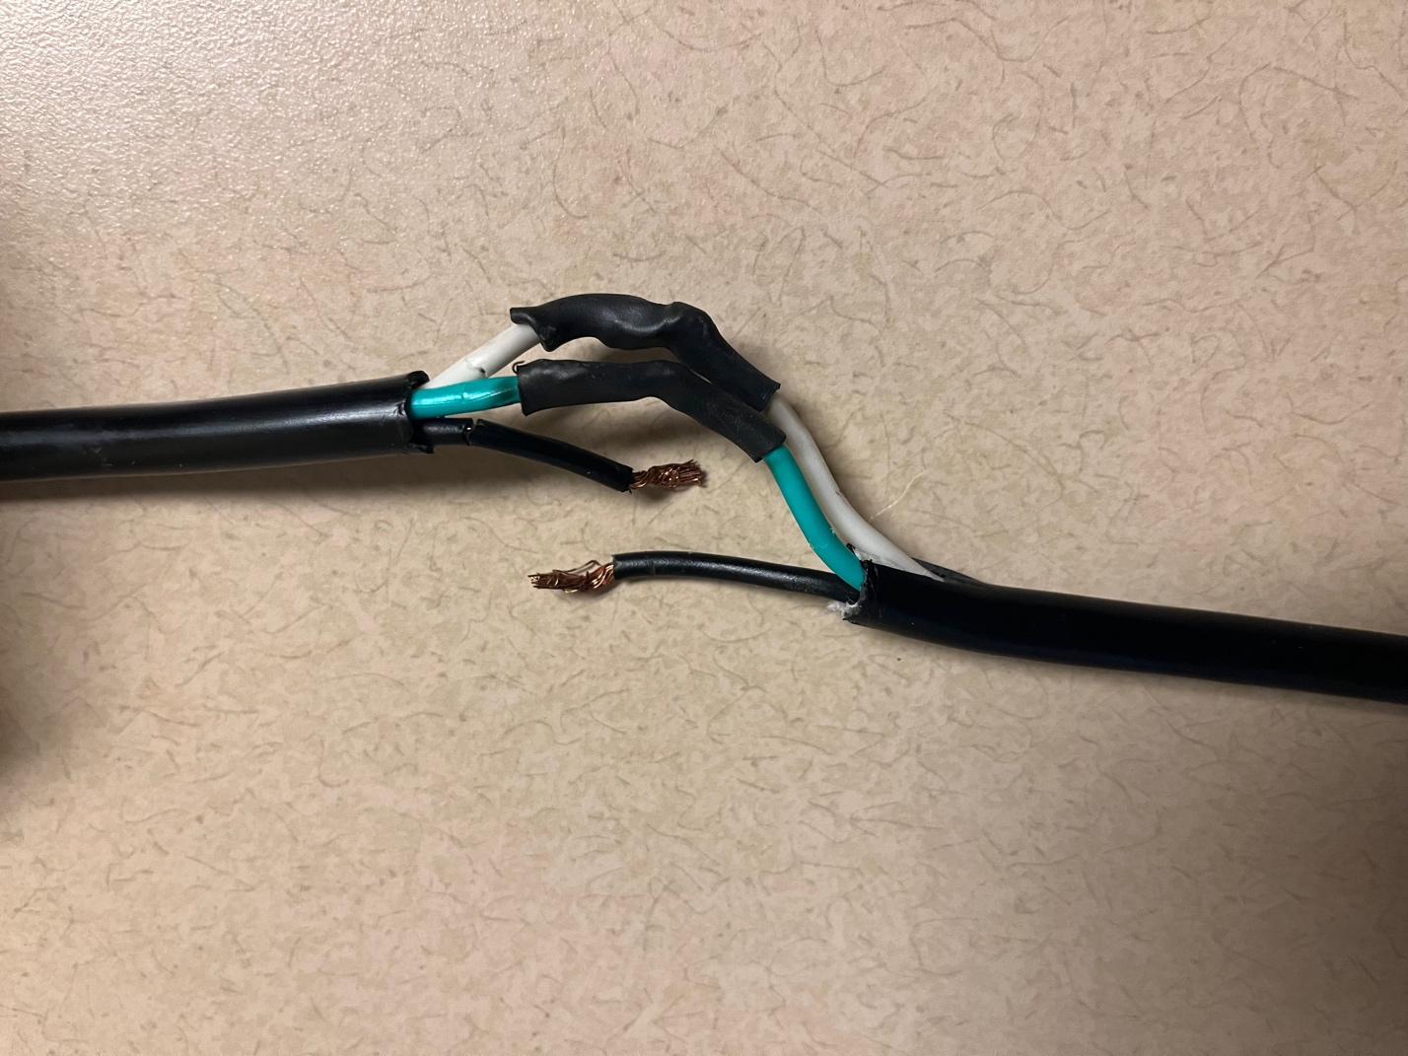

Figure 1. The inner wires of an extension cord. The black wire (power) will be connected through the Relay HAT. Any exposed wire core from the non-power wires is protected with black shrink tubing.

The Relay HAT that I used for my setup has three channels (but you can find Relay HATs with more or less channels, depending on your needs), each with a screw terminal block. Thread one end of the extension cord black wire to “NOx” and the other into “Cx” on one of the blocks, and secure by tightening with a flat head screwdriver (Figure 2).

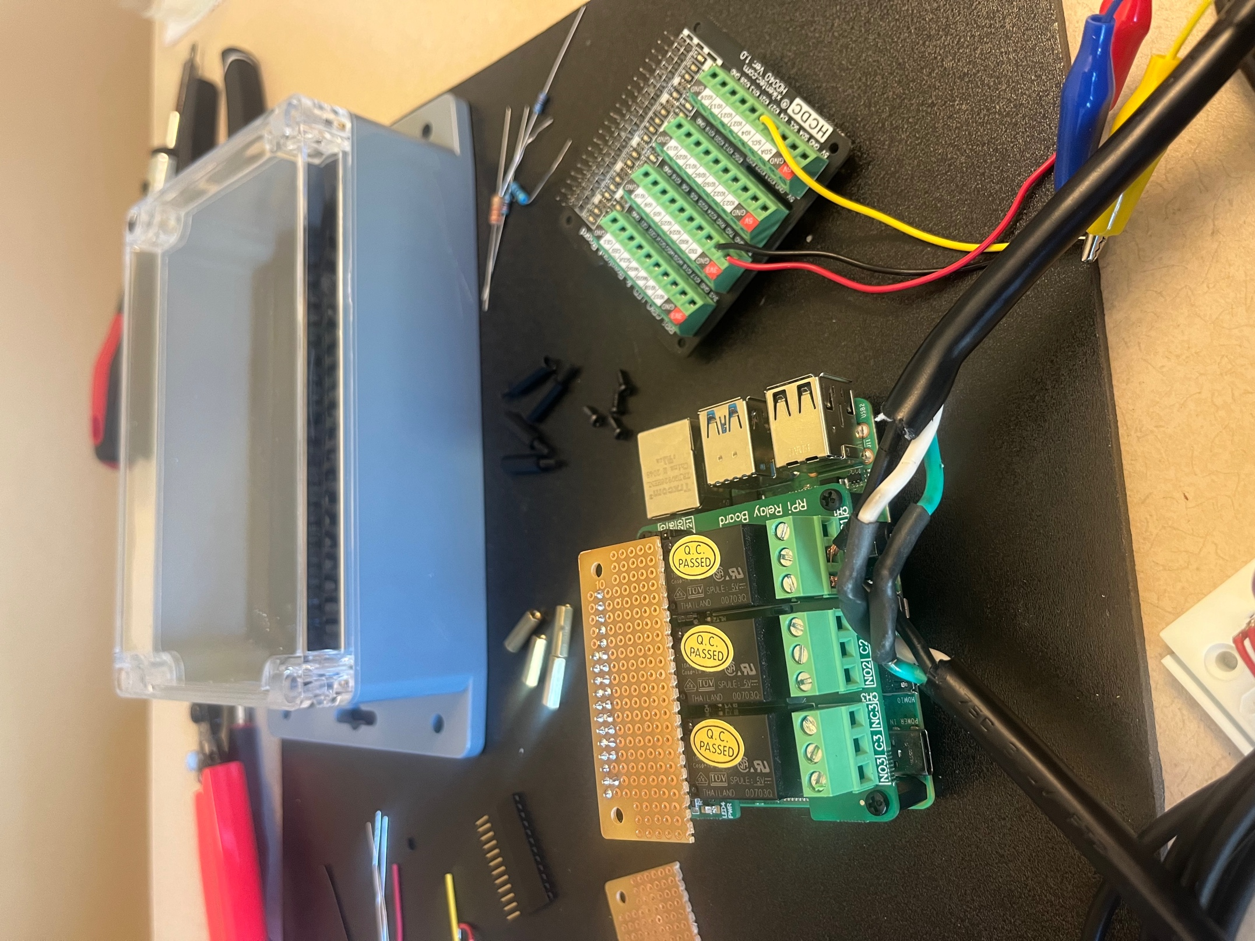

Figure 2. One extension cord plugged into a screw terminal on the Relay HAT.

**5. Preparing the Perma-Proto HAT**

The DS18B20 thermistors are connected to the Raspberry Pi via the Perma-Proto HAT. The thermistors come with three wires VDD (red), GND (black), and GPIO (white/yellow) (Figure 3)

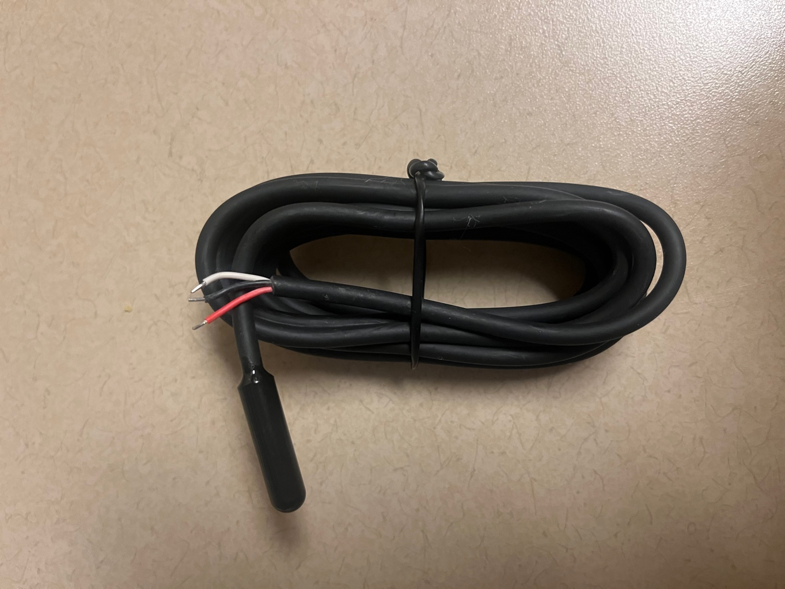

Figure 3. New DS18B20 thermistor with exposed wires, ready to be soldered.

Solder the header to the top row of the HAT, and then solder the various components to the Perma-Proto HAT following the schematic in Figure 4. Strip solid core wire and connect it each of the connections to the RPi headers (blue lines in Figure 4), and for applications with multiple thermistors, use stripped solid core wire to connect like wires across the board (orange lines in Figure 4). Solder a 1/8W 4.7k $Ω$ resistor between the VDD and GPIO lines, as shown in Figure 4. A complete example, with 18 thermistors and a 1/4W 3.2k $Ω$ resistor, is shown in Figure 5. Note: the more thermistors you add to the system, the greater the wattage and lower the resistance value you need for your resistor.

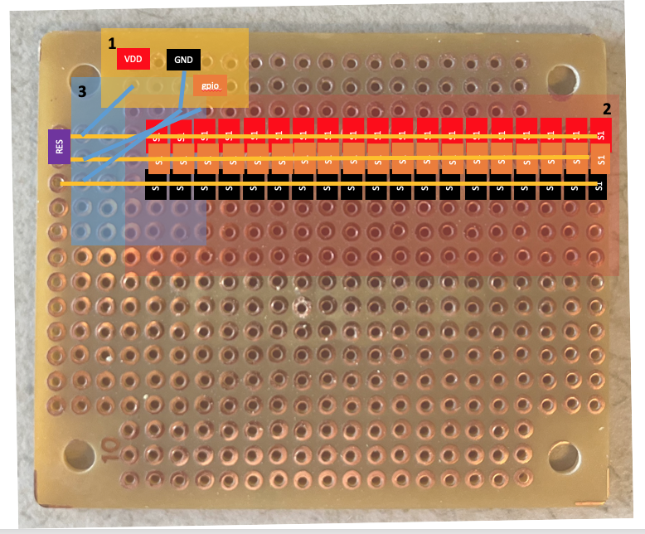

Figure 4. Perma-Proto HAT with locations for thermistor wires (region 2), resistor (region 3), and connections to the RPi header (region 1) to be soldered. It is recommended to solder region 1 first and region 3 last.

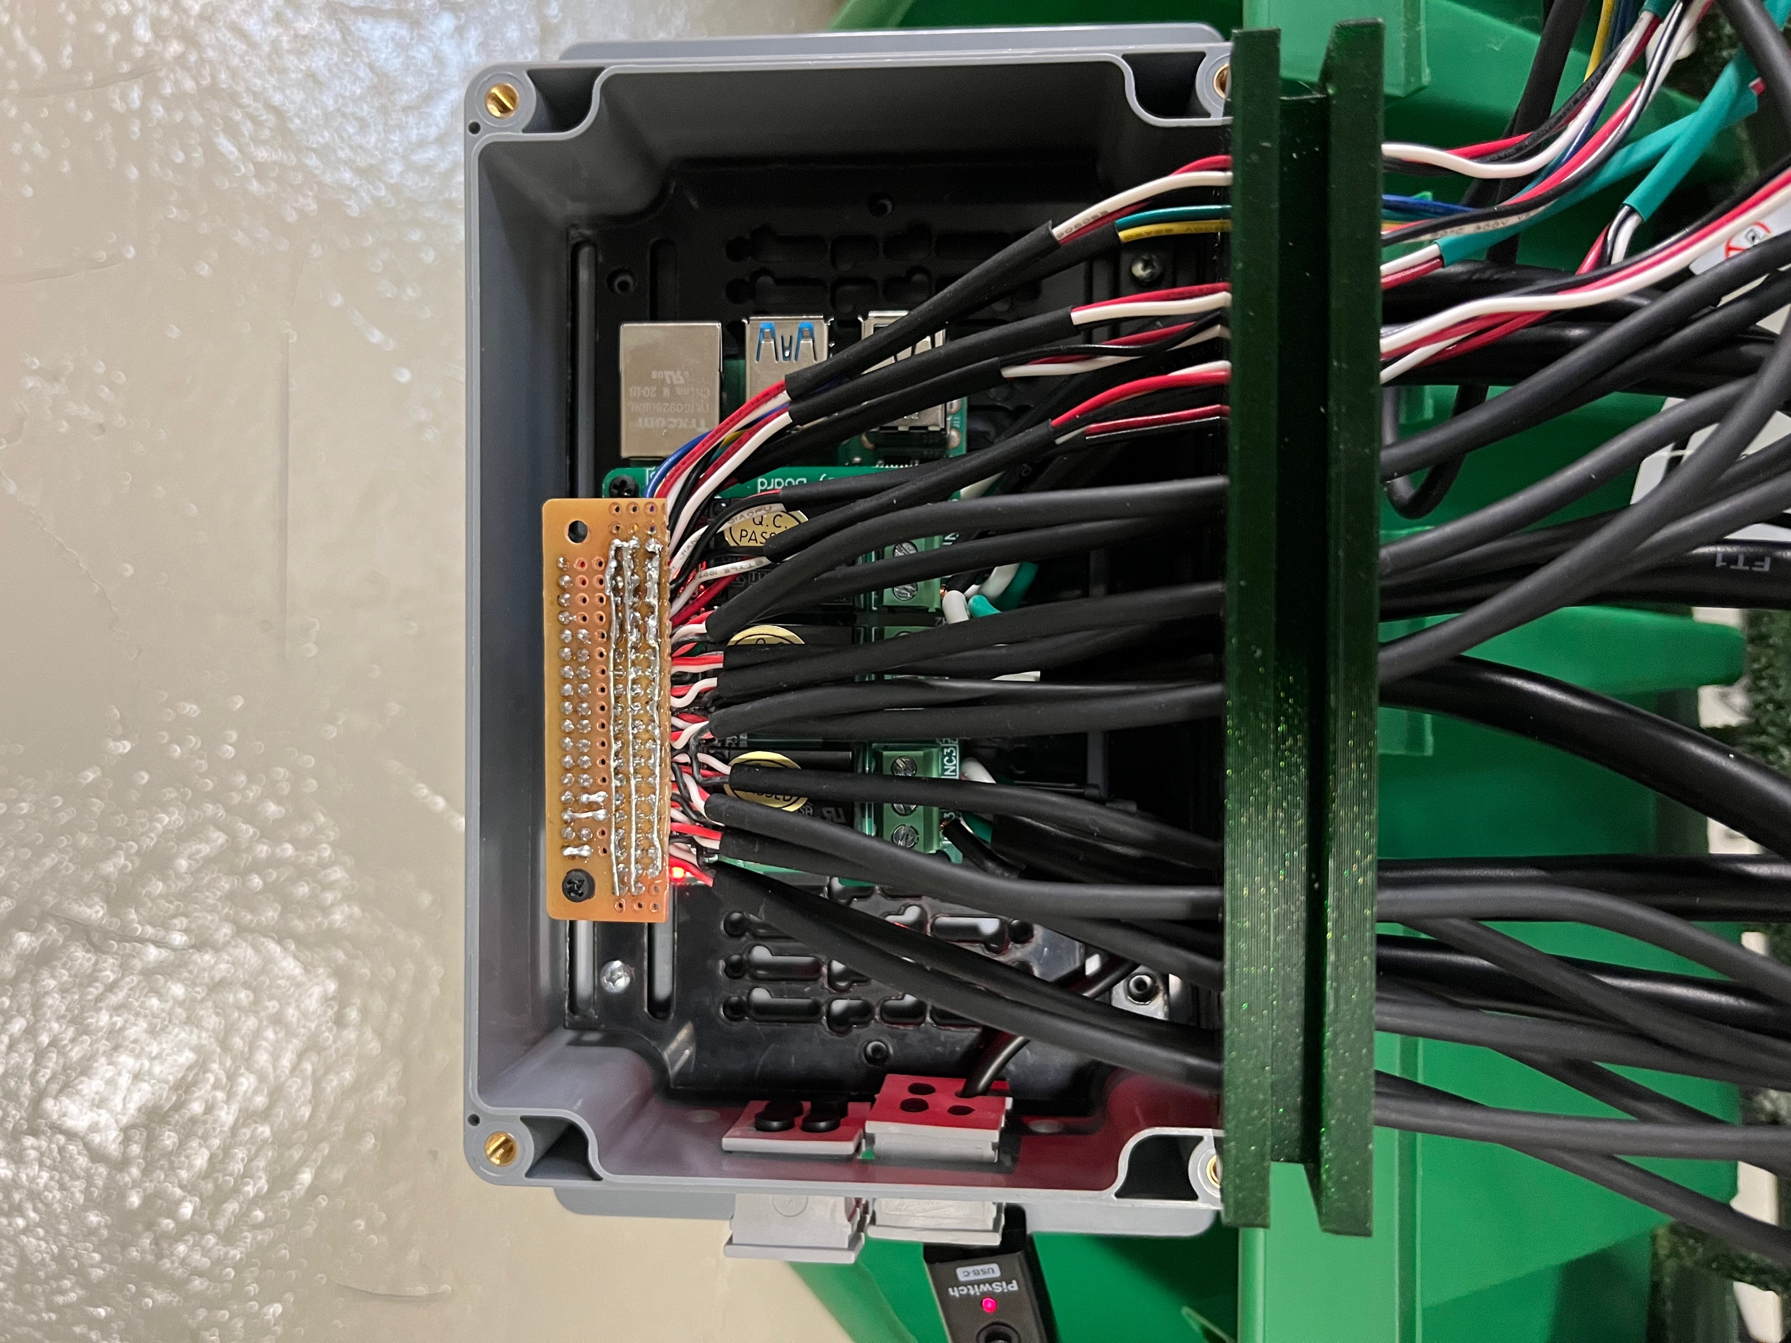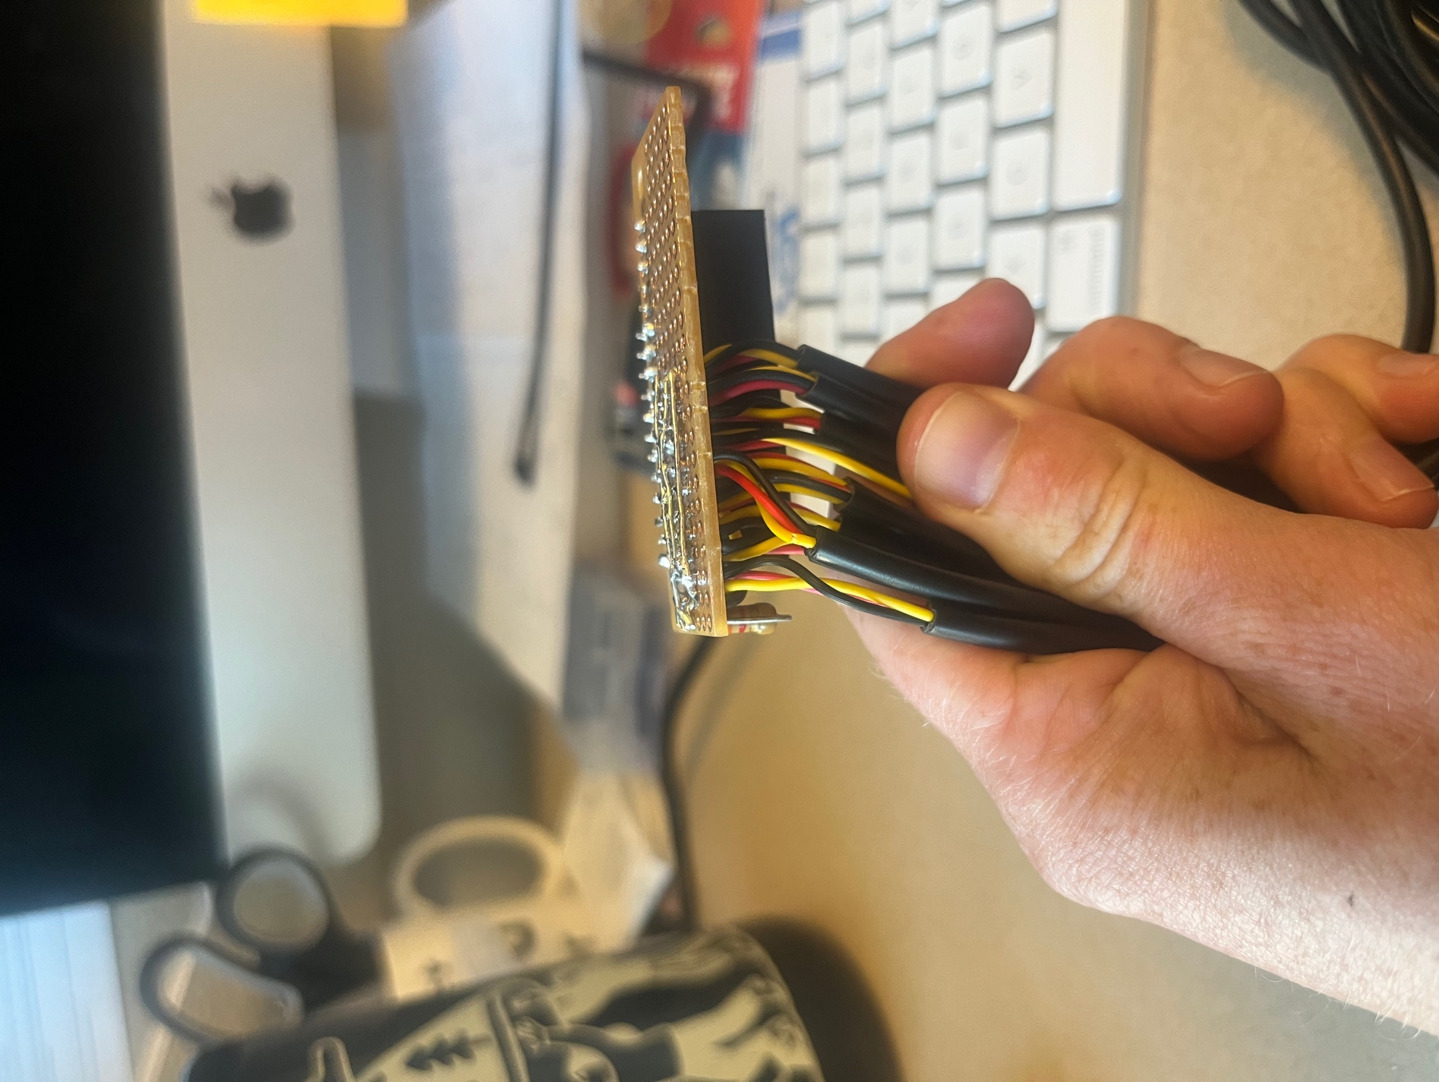

Figure 5. Top and side view of Perma-Proto HAT with all components soldered.

For more information about using DS18B20 temperature sensors with the RPi, read this tutorial: <https://www.circuitbasics.com/raspberry-pi-ds18b20-temperature-sensor-tutorial/>.

If you are still itching for more knowledge, read these two posts about interfacing multiple DS18B20 sensors with the RPi: <https://www.hackster.io/vinayyn/multiple-ds18b20-temp-sensors-interfacing-with-raspberry-pi-d8a6b0>, and <https://blog.cavelab.dev/2019/10/rpi-ds18b20-temp-sensors/>.

**6. Assembling the system**

Stack the Relay HAT on top of the Rasperry Pi, and then stack the Perma-Proto HAT on top of your Relay HAT (Figure 6). Use nylon screws to carefully secure the three boards to each other. Place the system inside your favorite waterproof case (there many [lower-cost](https://www.target.com/p/rubbermaid-brilliance-food-storage-container/-/A-53696326) and [higher-cost](https://sixfab.com/product/raspberry-pi-ip54-outdoor-iot-project-enclosure/) options). Now, you are ready to work on the code!

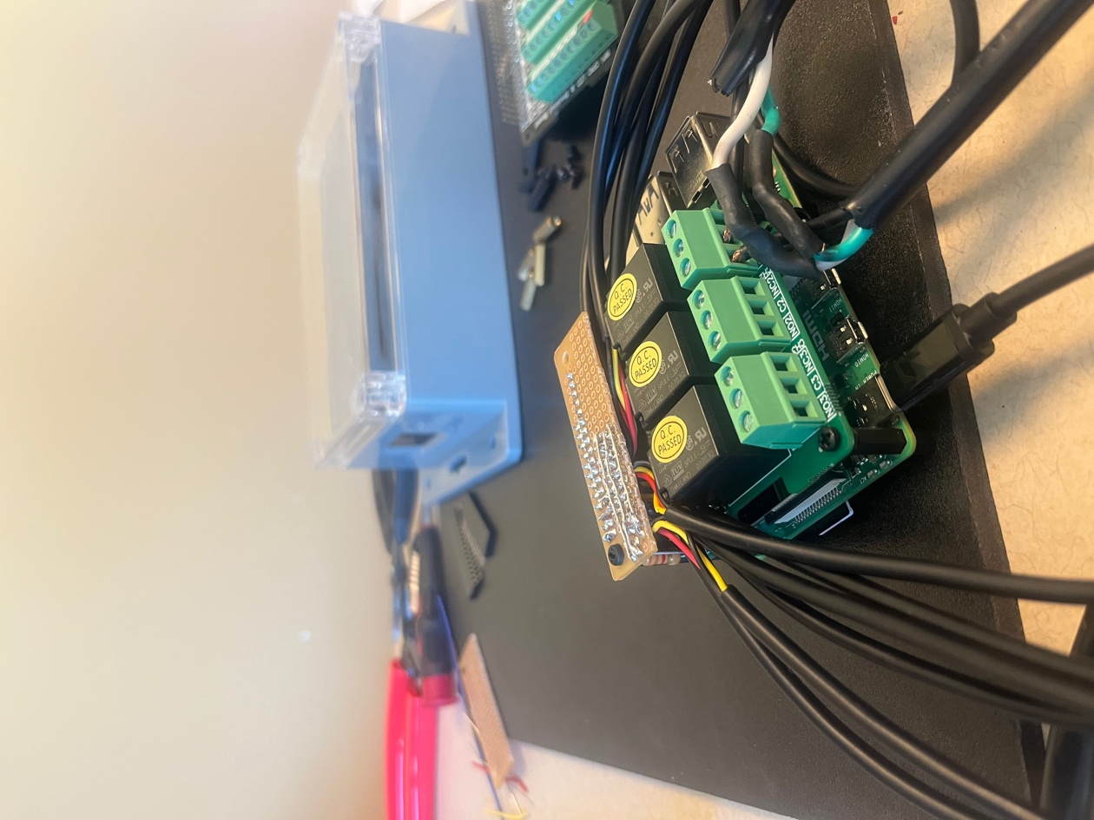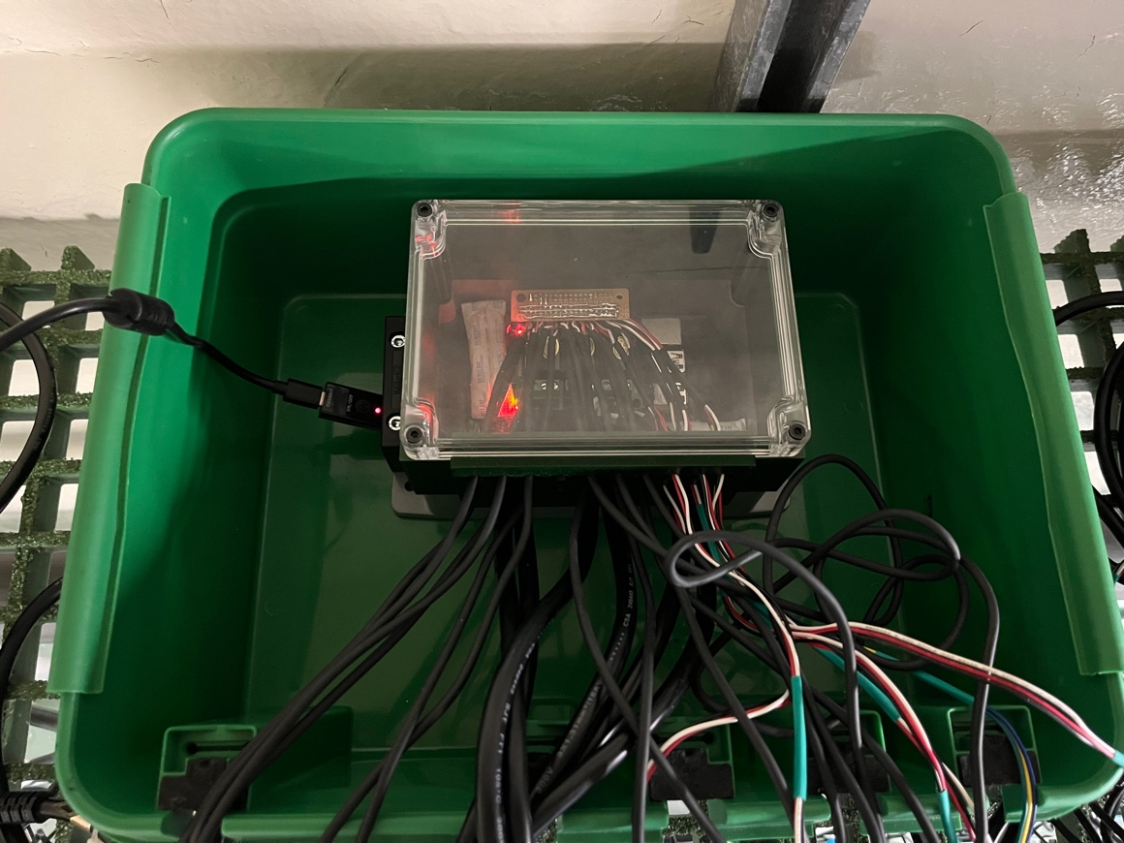

Figure 6. Fully assembled system (left) inside waterproof housing (right).

**7. Adapting the code to your experiment**

The project GitHub repository includes all the Python scripts you need to get started with your own MHWsim experiment.

1. Download all of the .py files in [code/python/](https://github.com/ameliaritger/MHWsim/tree/main/code/python) onto your Raspberry Pi. Also download the temperature profile (“mhw_profile.csv”; for testing purposes, you can delete this file or replace it as needed) contained within the same folder.
2. Download necessary packages (such as pandas and numpy) following the steps outlined in this post: <https://projects.raspberrypi.org/en/projects/generic-python-installing-with-pip>
3. Edit SensorInfo.py with your DS18B20 thermistor ROM numbers and calibration values for each probe. The ROM number will start with “28-” (see this link for more information on counterfeit DS18B20 chips: <https://github.com/cpetrich/counterfeit_DS18B20>).
   1. If you do not want to receive text alerts with your system, remove the line `import Alert` from main.py and Temperature.py.
4. Run main.py, and make note of any errors that pop up. Debug as needed.
5. If the code throws no errors, congratulations! You are now ready to begin adjusting the code to adapt it for your own experiment. As you make changes, remember to run the program often to check for errors!

A brief description of each script can be found below (in alphabetical order):

* **Alert.py** This script contains the information that allows your RPi to send SMS alerts when it encounters an error. Requires you to enter your RPi’s email address and password (sender) and an email address or Email-To-SMS address (receiver) that will receive the alerts.
* **CleanUp.py** This script saves the most recent temperature readings to a .csv file and re-initializes lists in preparation for the next loop before going to sleep.
* **IO_ctrl.py** This script initializes the relay board and sets up power switching to each pin (terminal block) on the relay board. Power On = HIGH and Power Off = LOW.
* **main.py** This is the main script which compiles and runs all of the code for the MHWsim.
* **Memory.py** This script constructs a .csv file to which your RPi will save data. Your thermistor information is also imported to create the file header (SensorInfo.py).
* **MHWRamp.py** This script allows for dictating temperature onset rates at the start of a MHW event and temperature decline rates at the end of a MHW event.
* **MHWsim.py** This script contains most of the information required for the RPi to run a MHW simulation experiment. It contains definitions such as: a temperature profile for the RPi to follow; temperature threshold(s) for MHW treatment(s); start date, end date, and duration of MHW event(s), and the frequency of thermistor sampling events.
* **PID.py** This script contains the Proportional-Integral-Derivative controller algorithm for temperature control in your system. The PID parameters are established in MHWSim.py, and are unique to every system. Read about PID Tuning at this link: <https://www.realpars.com/blog-post/pid-tuning>. If you do not want to take the (significant) time required to tune your system, set Kp, Ki, and Kd all equal to 0 in MHWSim.py.
* **SensorAverage.py** This script averages multiple consecutive temperature readings from the thermistors and calculates an average temperature across replicates within an experimental treatment, which is then printed to the console to allow for periodic checks by a human. The script generates lists of temperatures to be later saved in a .csv file.
* **SensorInfo.py** This script contains the thermistor ROM numbers and calibration values for each probe. Here, thermistors can also be grouped depending on the experimental design.
* **Temperature.py** This script defines reading data off the thermistors connected to the RPi.